American History Chapter 1
Lesson 1
Migration to the Americas

How did the first people and animals get to the Americas?
Theory- during the Ice Age, the water around the _________________ Strait became shallow. This exposed land that was once covered. The people and animals walked to the Americas on that land ________________.

Why did people begin to migrate from Asia to the Americas?
Theory- hunters may have __________________ the animals over the land bridge.

Life for the early people of the Americas was difficult.
- People depended on hunting wandering herds of ________________animals.
- When animals in one place were gone, they moved to begin a new hunt.
- People made tools from _______________

When the large animals died out, the way of life changed. People became…
Hunter-Gathers
- Began to hunt for ____________ animals and fish
- Gathered wild plants like ______________, nuts, and ____________
- Still had to ___________ to find more animals and plants.

Farmers
- Learned how to _________________ seeds and grew crops.
- People began to settle in one place and formed ________________________.

Climographs show the average ______________temperature and precipitation.

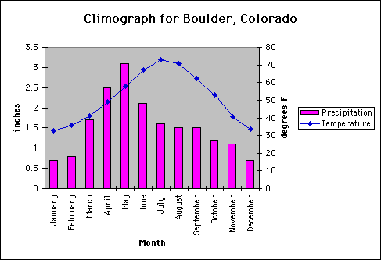

Lesson 2
Early American Cultures
The Mound Builders
- Lived east of the _______________________ River
- Farmers who _____________________ in communities
- Built mounds for ____________________ places or to honor animal spirits
- Religious __________________________ took place on the mounds
- Ability to build huge mounds showed they were an _______________________ culture

Anasazi
- Anasazi Lived in the _____________________
- Grew corn, ________________, beans, and pumpkins
- Lived in _______________________
- First people in the U.S. to use______________ to water crops
- Called “cliff dwellers” because they ________________ houses in the sides of ___________________
Inuit
- Lived in ___________________ near the Arctic Ocean
- Traveled from Asia to North America, but came much _____________________ than the others
- Hunted whales and _______________________
- Developed the _____________________
- Lived in houses called ___________________

Lesson 3
The Rise of Empires
Civilization - a culture with an ______________________ system of government, religion, and learning.
Surplus – more food or good than ___________________
Specialize- to do only _______________ kind of job
Pyramid- a building with three or more sides shaped like ______________________ that slant toward a pointed top
The Mayan Empire
- Maya were successful ______________________
  - Grew a ____________________ of food
  - People with extra food ___________ it for needed items
  - As a result, people began to _________________ in jobs
    - Basket weaving
    - Jewelry making
    - Stone carving
- Because of specializing, Maya developed a _______________ civilization with many achievements
  - Studied the movements of the _______, moon, and stars
  - Developed an extremely accurate ______________
  - Skilled at _____________-the first group to use the number 0
  - Developed methods to build tall ___________________
  - Developed a system of ___________________ and recorded their history
The Aztec Empire
- Settled in the valley of ____________________ and built city of Tenochtitlan
- Created floating ____________________, developed irrigation systems and carved ________________________ into hillsides to make more farmland
- Sent out armies to _____________________ other people
- Built a great empire by forcing others to pay ______________ and become ____________________.
The Incan Empire
- Incan empire grew in _________________ America
- Created empire through _____________ of other people
- Built thousands of miles of _________________ to connect all parts of the empire to their capitol at _________________.

